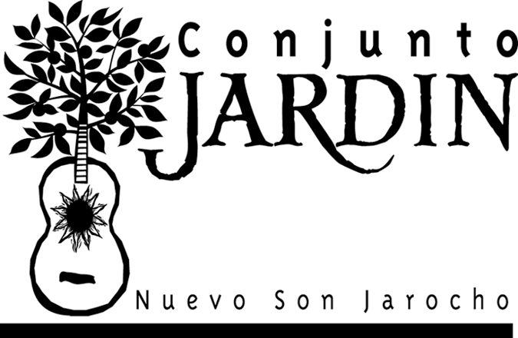

“Conjunto Jardín ... is built around the convincing, traditional-styled singing and playing of sisters Libby and Cindy Harding. Their music ...was almost instantly captivating, generating dancing in the aisles....
It was a superb example of the manner in which traditional music and dance continue to have the power to reach out and gather in new, receptive audiences.”
— Don Heckman, Los Angeles Times

Conjunto Jardín: “La Rama” (Floreando, Trova)
“Everything folks on this list have said praising this group is true and then some; they're one of the most exciting and delightful revival bands I’ve heard in years. Whether or not you think you like Mexican music, you really, really should hear this recording!”
— Paul Stamler, KDHX, St. Louis, MO

“Los Angeles-based Conjunto Jardín play a vigorous brand of son jarocho, the exciting, polyrhythmic music of Veracruz, Mexico. Led by sisters Cindy and Libby Harding (daughters of folk/world music pioneer Tim Harding), Conjunto Jardín both honors and expands jarocho tradition, exploring the music’s little–appreciated African influences, and creating their own joyful, percolating sound. Recommended.”
— Sing Out!

“... a stunning neo-traditionalist performance... vocally rich harmonic delivery with an infectious dance-happy energy.... sterling sonic reflection and impeccable musicianship.... ¡Vámonos al jardín!”
— Chuy Varela, Latin Beat

“Of the eight types of traditional Mexican son, the son jarocho of Veracruz rocks the hardest.... Local aficionados Conjunto Jardín have taken this folkloric form and made it their own. Led by the sibling vocals and hard-charging jarana and requinto of Libby and Cindy Harding and the incredible keyboard-harp simulations of Gary Johnson, the group brings out the music’s African roots and Caribbean connections on their first CD, Nuevo Son Jarocho (Trova).”
— Tom Cheyney, LA Weekly

“Without denying tradition, this postmodern treatment of the century-old son jarocho deserves taking off one’s hat, throwing it to the ground and dancing to the rhythm of the group of jarana-playing Harding sisters...”
— Ricardo Camerena, La Opinión

“People would have been up and dancing, had there been any room.... With the audience on its feet (and how one could have remained seated with such powerful rhythms is beyond me), the group quickly returned for an encore ... before leaving a satisfied audience to file out into the cool night air.”
— Jim Lee, Dirty Linen

“The sisters and their quintet make music that is infectious, lively, and uplifting....”
— Larry Kelp, East Bay Express

“. . . hands-down, the liveliest of Mexico’s folk string-ensemble traditions. Some listeners may recognize the genre’s lyrical strains from the work of Los Lobos, but since 1997, Conjunto Jardín has been the music’s most dedicated North American proponent....
The unsuspecting listener may be surprised to learn that the sextet boasts only one Mexican musician, the balance hailing from the U.S. and Benin. But that footnote takes nothing away from the remarkable work of a band that rightfully earned rave reviews for its recent, invited appearance at the annual world summit of jaraneros in Tlacotalpan, Veracruz.... [S]imultaneously honors the son jarocho’s inspirational source and celebrates its efflorescent multicultural future.”
— Michael Stone, fRoots

“Conjunto Jardín has captured the essence of the son jarocho; it is impressive how they have replicated the core elements of traditional style without merely imitating or sounding wooden. Of particular note is the use of keyboard synthesizer to render the part of the diatonic harp ⎯ pristine, yet virtually indistinguishable from the original sound. The voices are attractive in sound and seamlessly interwoven in parallel harmonies. Cindy Harding’s requinto playing is traditional, tasteful, and tightly in synch with the fast-moving rhythmic pulse. Conjunto Jardín’s music is both traditional and possessed of a fresh vision of potential cultural blendings of African-derived musical ingredients.”
— Dan Sheehy, ethnomusicologist and arts administrator

“This is wonderful, sparkling, traditional music played with gusto, verve and joy.” (Best albums of 1998)
- Chuck Taggart, KCSN “Down Home,” Northridge, CA

“Talk about a flowering garden? This is a beautiful recording, which I just received for airplay on “Roots and Wings,” my weekly folk music program in the Pocono Mtns of NE Pennsylvania. There is a light-hearted Christmas song, “La Rama,” which might be described as a Mexican wassail with improv (ideal for the holiday season), and a fascinating glimpse of the Afro-Mexican ties between Veracruz, on the Gulf of Mexico, and West Africa, from which many slaves were transported, “De Puerto en Puerto,” as another of the songs sings in a defiantly happy tribute to the human spirit (the very informative notes point to the African roots of such songs as “El Torito/El Toro Zacamandu” [The Little Bull/The Magic Bull]). Another song, a sea-shanty, “El Coco,” about a sea-bird, borrowed from marineros plying their trade between Cuba and Veracruz ⎯ sung in Benin by African-born percussionist Marcel Adjibi ⎯ underscores this centuries-old link between the Old World and the New, specifically in the Mexican Gulf coast State of Veracruz and its main port.
Conjunto Jardín is the flowering of the work of Prof. Tim Harding, who made field recordings of Mexican regional music in the early 1950s for Moses Asch's Folkways Records, and has since gone on, not only to recall his Mexican students at Cal State LA (in the middle of East LA) to their Chicano roots, but also to encourage his daughters, Libby and Cindy, to carry on this work. The sound is brilliant but melodic, and the syncopated rhythms lend a jazzy feel to the selection of “son jarocho” (the music of Veracruz) represented here by a younger generation of multicultural musicians, not only the Harding sisters (vocals, various guitars, flute), and Marcel Adjibi (congas, talking drums, vocals), but also Mexican-born multi-instrumentalist Jorge Mijangos and Rick Moors (El Tiburon [The Shark]) on bass. This is a rich and lovely addition to your record library, and worth more than a few spins on any folk music program venturing beyond the Anglo tradition.
Thank you, Conjunto Jardín, and thank you, Prof. Harding.”
— John McLaughlin, WESS, E. Stroudsburg, PA

